

**Course Name:** Database Management Systems- II

**Course Code:** CPS 562 01

**FINAL PROJECT**

**ON**

**FRIENDBOOK**

*Submitted by:*

**CHANDRA SEKHAR YELLAPU (1016356770)**

**PUNNA YASHWANTH KUMAR (1016238420)**

*Submitted to:*

**Dr.** [**BUCKLEY,**](http://www.udayton.edu/directory/artssciences/computerscience/courte_dale_e.php) **JAMES**

Associate Professor; Director of Graduate Program in Computer Science

University of Dayton

­­

**SOFTWARE REQUIREMENTS:**

**ER DIAGRAM**

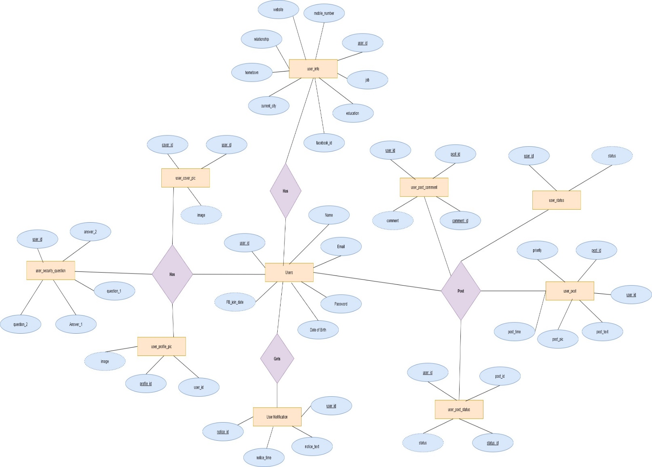

**DATABASE INSTANCE:**

A database **instance** or an ‘instance’ is made up of the background processes needed by the [database software](http://ecomputernotes.com/sql/sql-tutorials/whatissql). These processes usually include a process monitor, session monitor, lock monitor, etc.

**User Instance:**

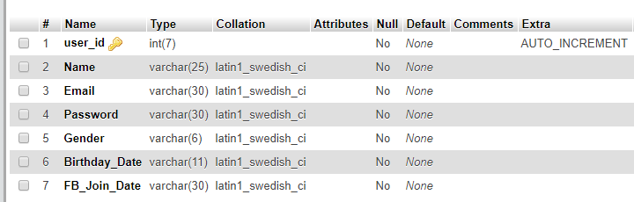

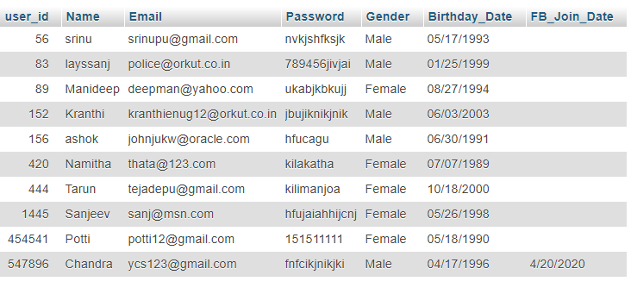

**User Info Instance:**

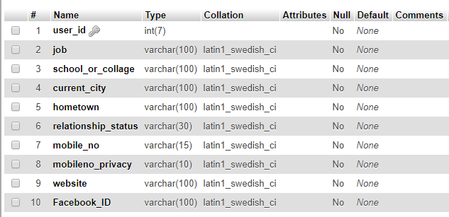

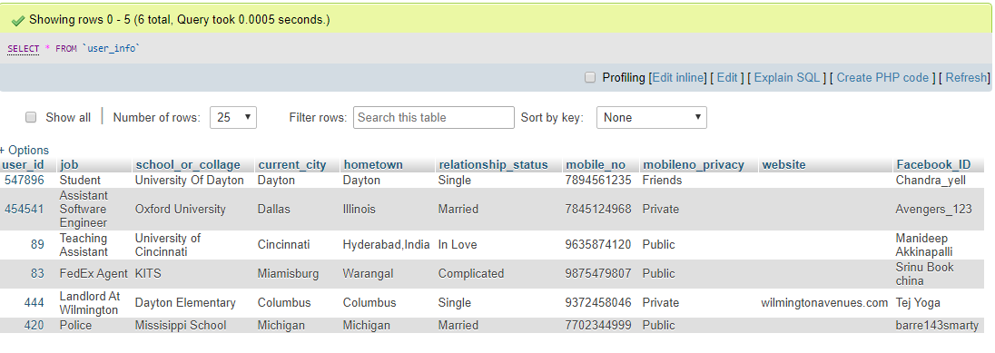

**User Post Instance:**

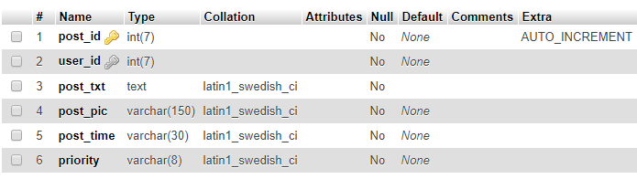

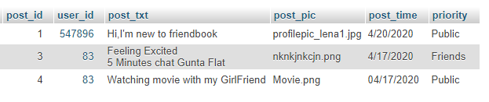

**User Notification Instance:**

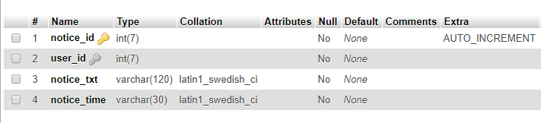

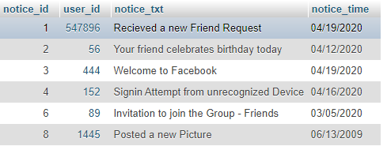

**Web Interface**

**Login Page**

User enters the Username and Password if he already has an account with Facebook and can login to his with his credentials

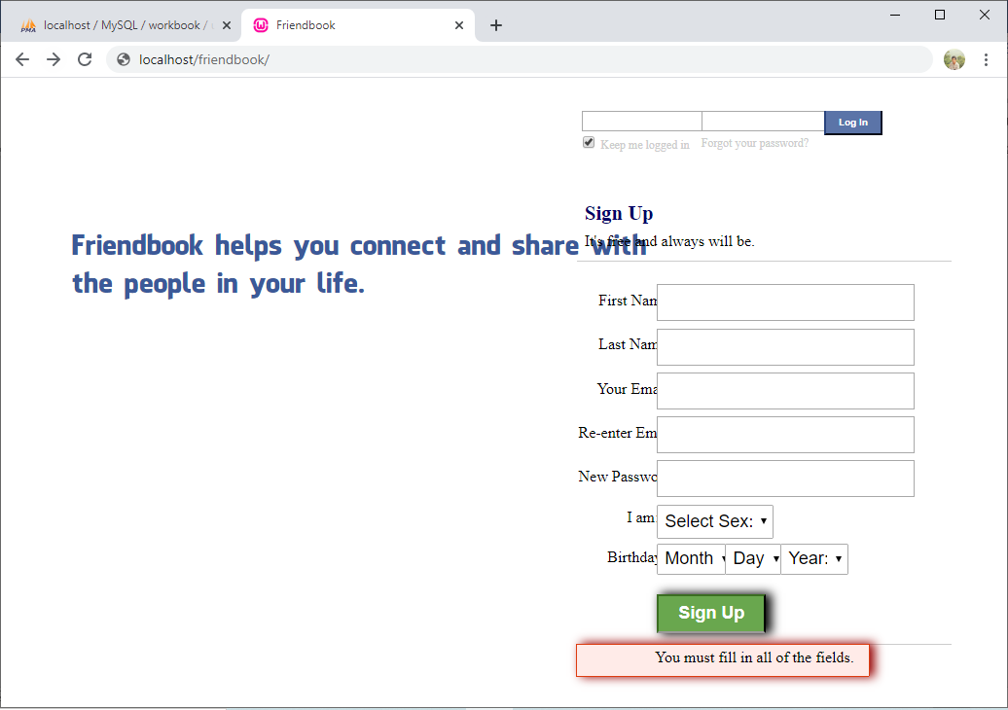

**Post Status:**

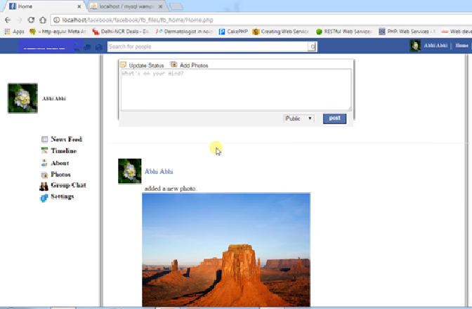

**Add Cover Picture:**

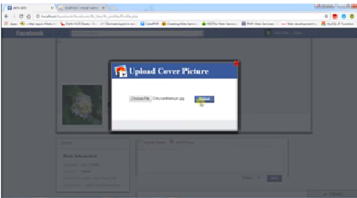

**Queries:**

1**.**Display the tables created in the Database

Database **workbook** and its tables

**SQL Query:**

show tables

**Query Result:**

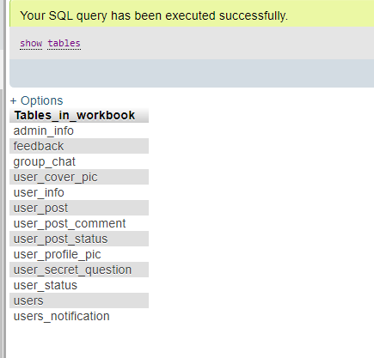

2.Create Table with set of column names and type of data and size of it includes if any primary or foreign keys

**SQL Query:**

CREATE TABLE `users_notification` (

`notification_id` int(7) NOT NULL AUTO_INCREMENT,

`user_id` int(7) NOT NULL,

`notification_txt` varchar(120) NOT NULL,

`notification_time` varchar(30) NOT NULL,

PRIMARY KEY (`notification_id`),

KEY `user_id` (`user_id`)

)

**Query Result:**

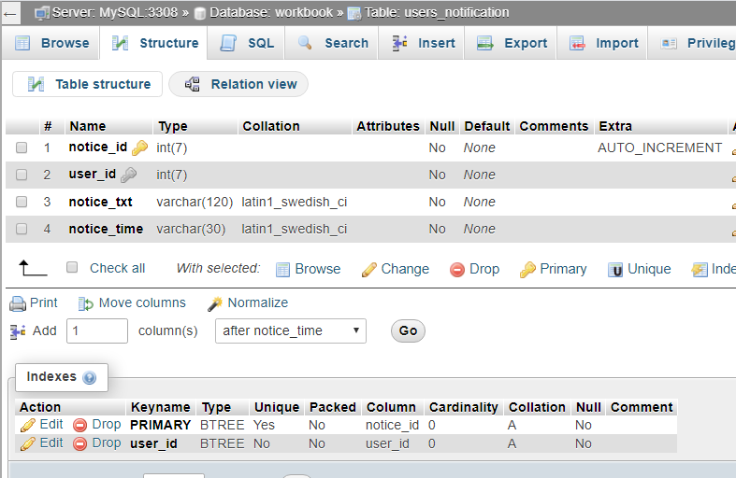

3.List the users who are MALE

**SQL Query:**

[SELECT](http://localhost/phpmyadmin/url.php?url=https://dev.mysql.com/doc/refman/5.5/en/select.html) Name,Email,Gender,Birthday_Date

FROM `users`

WHERE Gender='Male';

**Query Result:**

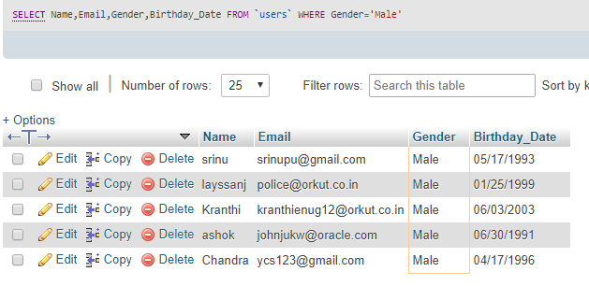

4. Delete Duplicate rows from the table user_security_question

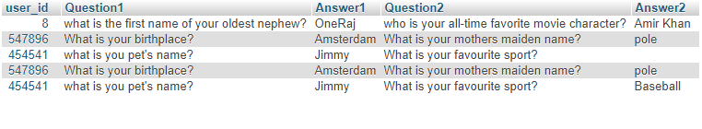

**SQL Query:**

DELETE from user_secret_question

WHERE Answer2 not in

(

SELECT MAX(user_id)

FROM user_secret_question

GROUP BY user_id

);

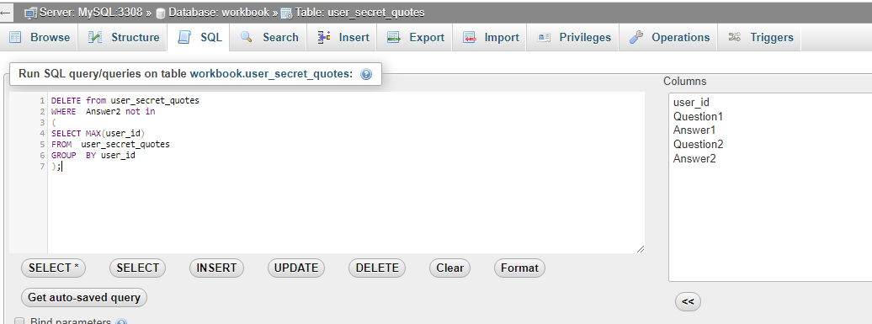

**Query Result:**

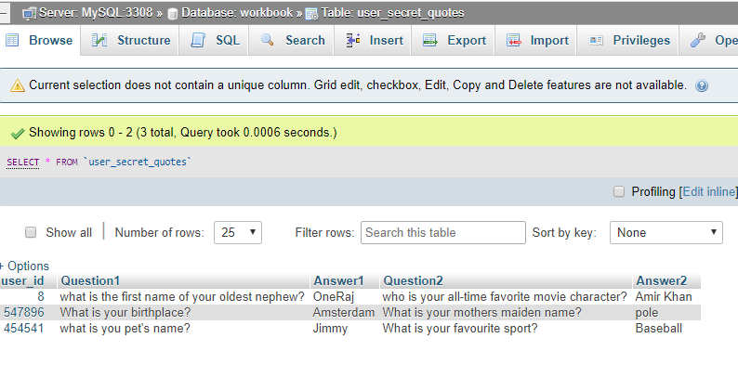

5. Insert Data into the tables

**SQL Query:**

INSERT INTO `security_question` (`user_id`, `Question1`, `Answer1`, `Question2`, `Answer2`) VALUES

(8, 'what is the first name of your oldest nephew?', 'OneRaj', 'who is your all-time favorite movie character?', 'Amir Khan');

**Query Result:**

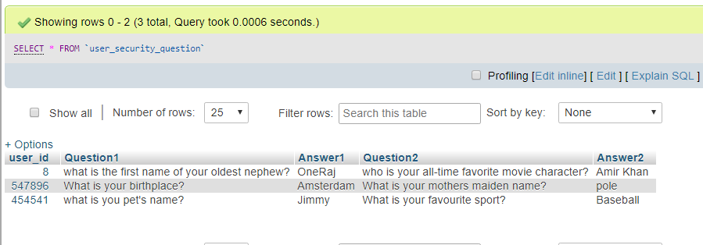

6. Display the structure of user info

**SQL Query:**

describe user_info;

**Query Result:**

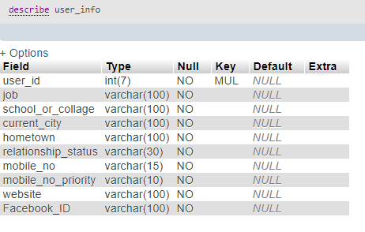

7. Rename table in workbook database

**SQL Query:**

[RENAME](http://localhost/phpmyadmin/url.php?url=https://dev.mysql.com/doc/refman/5.5/en/rename-table.html) [TABLE](http://localhost/phpmyadmin/url.php?url=https://dev.mysql.com/doc/refman/5.5/en/rename-table.html) `workbook`.`user_secret_questions` TO `workbook`

.`user_secret_question`;

**Query Result:**

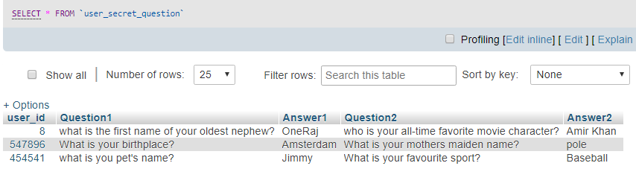

8. View the notifications for the particular user

**SQL Query:**

SELECT users_notification.notice_txt, users.Name, users_notification.notice_time

FROM users_notification

INNER JOIN users ON users_notification.user_id=users.user_id;

**Query Result:**

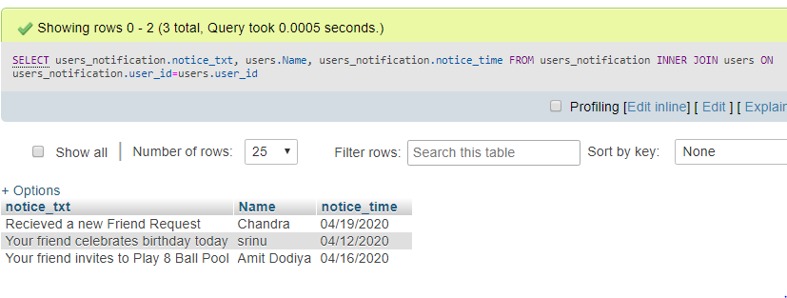

9. Display the posts made by the user on one’s Own Profile

**SQL Query:**

[SELECT](http://localhost/phpmyadmin/url.php?url=https://dev.mysql.com/doc/refman/5.5/en/select.html) users.Name,user_post.post_txt,user_post.post_time,user_post.post_pic

from users INNER JOIN user_post

ON users.user_id=user_post.user_id [AND](http://localhost/phpmyadmin/url.php?url=https://dev.mysql.com/doc/refman/5.5/en/logical-operators.html#operator_and) users.user_id=83

**Query Result:**

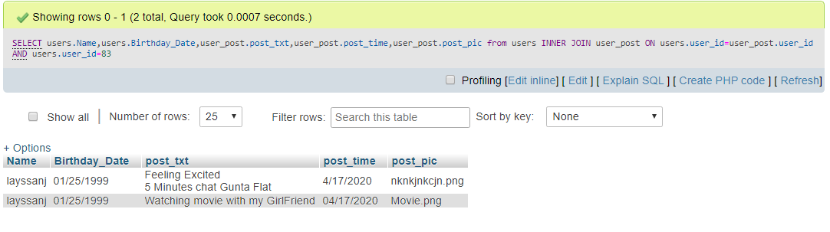

10.List the comments made on the posts

**SQL Query:**

[SELECT](http://localhost/phpmyadmin/url.php?url=https://dev.mysql.com/doc/refman/5.5/en/select.html) U.Name, U.Gender,P.post_txt,P.post_pic,C.comment

FROM users AS U

JOIN user_post P

ON U.user_id = P.user_id JOIN user_post_comment C

ON C.post_id=P.post_id;

**Query Result:**

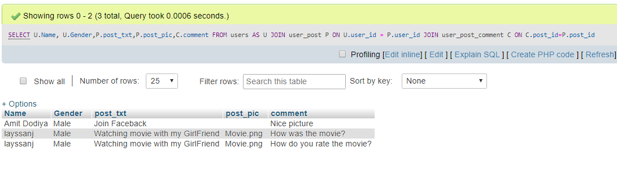

------------------------------------------------------------------------------------------------------------------------------------------

**OBSERVATIONS**

* This project helps one to learn an efficient database design and its implementation in the real world.
* This implementation helps in better insight of the course. The initial journey started by database design.
* Conversion of bare data into a structural form i.e. tabular form so that it could be used for storage and retrieval of large amount of data by storing in tables is explained.
* Complex things were designing relations, attributes and associations between these relations, identification of keys and constraints.
* Challenging part was prevention of redundancy.
* JavaScript to connect the front-end PHP, HTML and its application using CSS framework are well understood.
* This project is helpful in learning the creation of ones own well-structured database and its implementation.